Project Title:
SESP College Complaint Portal – Complaint Management System

Submitted by:
Javeriya Jamadar
CM6K

Submitted to:
Mrs M.S.Dussa
Institution:
SESP College

Year:
2025-2026

Introduction
The SESP College Complaint Portal is a web-based application developed to simplify the process of submitting and managing complaints within the college. Traditionally, students report issues through manual processes which can be slow and difficult to track.
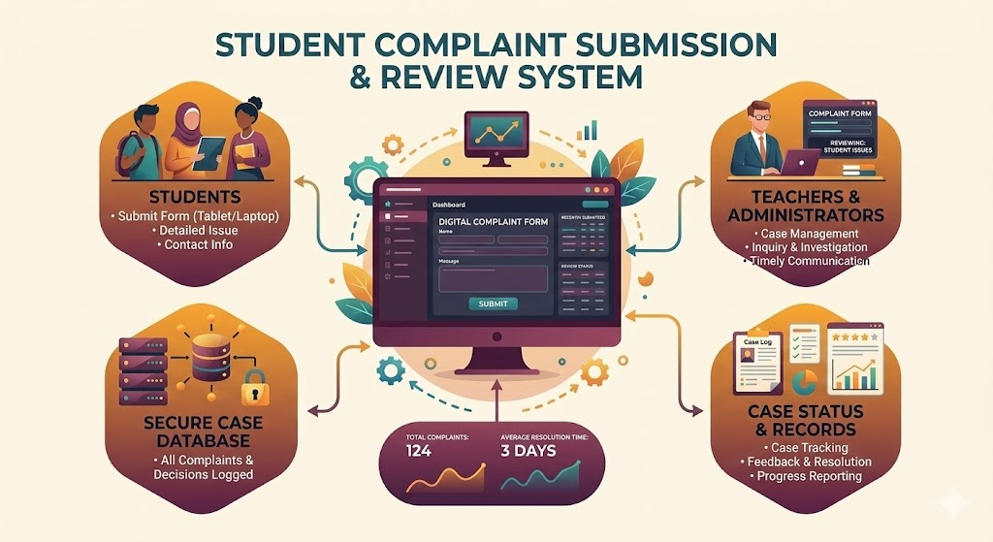
This system allows users to submit complaints related to various categories such as infrastructure, academic issues, or administrative concerns. Each complaint is stored and displayed in the system where it can be reviewed and updated.
The application is built using React.js, which provides a dynamic and responsive user interface. The system enables users to add, view, update, and delete complaints efficiently.
This project demonstrates how modern web technologies can be used to build simple management systems that improve communication and transparency within an institution.

Objectives
The main objectives of the project are:
- To create a platform where students can submit complaints easily.
- To organize complaints by category.
- To allow complaints to be tracked and managed.
- To provide a simple and user-friendly interface.
- To demonstrate the use of React.js for web application development

Technologies Used
Technology | Purpose
React.js | Frontend development
JavaScript | Application logic
HTML | Structure of the web page
CSS | Styling and layout
Node.js | Runtime environment
VS Code | Development environment

System Flowchart
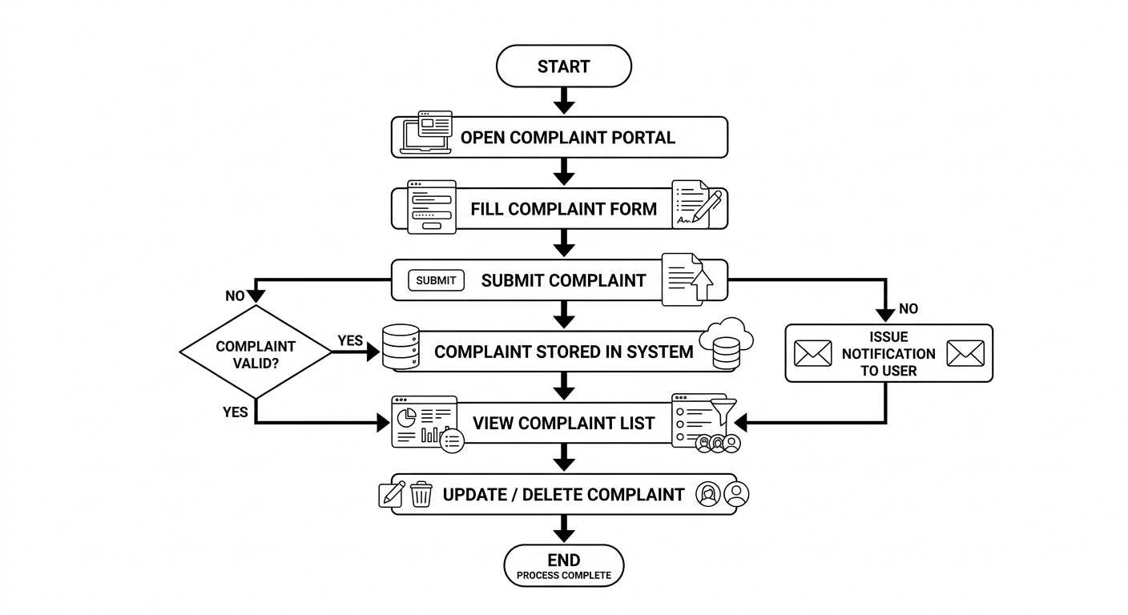

Block Diagram
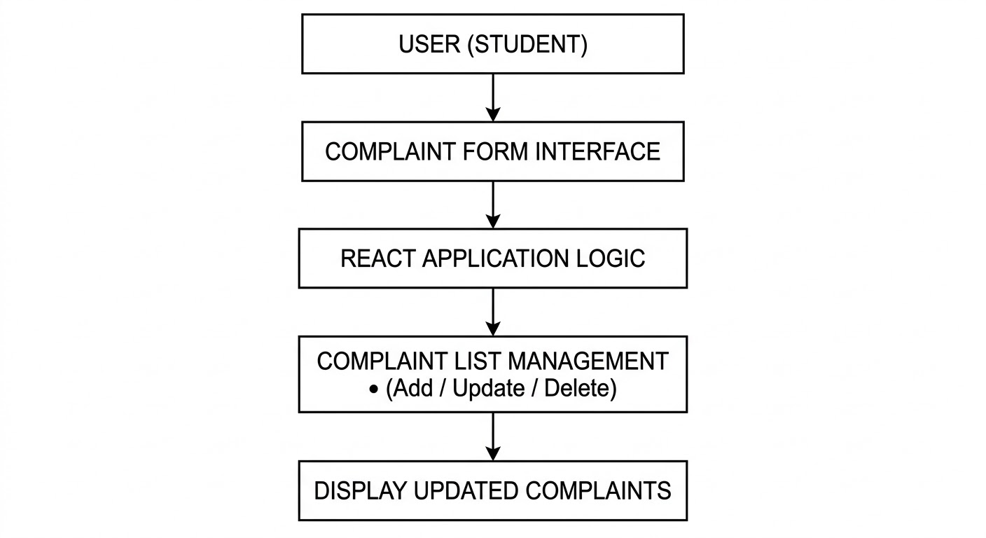

Source Code

App.js
import React, { useState } from "react";
import ComplaintForm from "./ComplaintForm";
import ComplaintList from "./ComplaintList";
import "./App.css";
function App() {
const [complaints, setComplaints] = useState([]);
const addComplaint = (complaint) => {
setComplaints([...complaints, complaint]);
};
const updateStatus = (id, newStatus) => {
setComplaints(
complaints.map((comp) =>

comp.id === id ? { ...comp, status:
newStatus } : comp
) ); };
const deleteComplaint = (id) => {
setComplaints(complaints.filter((comp) => comp.id !== id));
};
return (
<div className="main-wrapper">
<div className="left-section">
<img
src="https://cdn-icons-png.flaticon.com/512/3135/3135789.png"
alt="complaint"
/>
<h2>Raise Your Voice</h2>
<p>Your complaints help us improve the system.</p>
</div>
<div className="right-section">
<h1>SESP College Complaint Portal</h1>
<ComplaintForm addComplaint={addComplaint} />
<ComplaintList
complaints={complaints}
updateStatus={updateStatus}
deleteComplaint={deleteComplaint}
/>
</div>
</div>);}
export default App;

ComplaintCard.js
import React from "react";

function ComplaintCard({ complaint, updateStatus, deleteComplaint }) {
return (
<div className="card">
<h3>{complaint.name}</h3>
<p><strong>Department:</strong> {complaint.department}</p>
<p><strong>Type:</strong> {complaint.type}</p>
<p><strong>Message:</strong> {complaint.message}</p>
<p><strong>Status:</strong> {complaint.status}</p>
<div className="buttons">
<button onClick={() => updateStatus(complaint.id, "In Progress")}>
In Progress</button>
<button onClick={() => updateStatus(complaint.id, "Resolved")}>
Resolved
</button>
<button onClick={() => deleteComplaint(complaint.id)}>
Delete
</button>
</div>
</div>
);}

export default ComplaintCard;
ComplaintForm.js
import React, { useState } from "react";
function ComplaintForm({ addComplaint }) {
const [name, setName] = useState("");
const [department, setDepartment] = useState("");
const [type, setType] = useState("Academic");
const [message, setMessage] = useState("");
const handleSubmit = (e) => {
e.preventDefault();
if (!name || !department || !message) {
alert("Please fill all fields");
return;
} const newComplaint = {
id: Date.now(),
name,
department,
type,
message,
status: "Pending",
};
addComplaint(newComplaint);
setName("");
setDepartment("");
setType("Academic");
setMessage("");};
return (
<form onSubmit={handleSubmit} className="form">
<input
type="text"
placeholder="Student Name"
value={name}
onChange={(e) => setName(e.target.value)}
/>
<input
type="text"
placeholder="Department"
value={department}
onChange={(e) => setDepartment(e.target.value)} />
<select value={type} onChange={(e) => setType(e.target.value)}>
<option>Academic year</option>
<option>1st</option>
<option>2nd</option>
<option>3rd</option>
</select>
<textarea
placeholder="Write your complaint..."
value={message}
onChange={(e) => setMessage(e.target.value)}
></textarea>

<button type="submit">Submit Complaint</button>
</form>
);}
export default ComplaintForm;
ComplaintList.js
import React from "react";
import ComplaintCard from "./ComplaintCard";
function ComplaintList({ complaints, updateStatus, deleteComplaint }) {
return (
<div className="list">
<h2>All Complaints</h2>
{complaints.length === 0 && <p>No complaints yet.</p>}
{complaints.map((comp) => (
<ComplaintCard
key={comp.id}
complaint={comp}

updateStatus={updateStatus}
deleteComplaint={deleteComplaint}
/>
))}
</div>
);
}
export default ComplaintList;

Idea Behind the Project
The idea behind making this project is to understand how organizations handle and resolve customer complaints effectively. Complaint management plays an important role in maintaining customer satisfaction and improving the quality of products and services.
Through this project, I aim to study the importance of listening to customer feedback, identifying problems, and taking proper actions to solve them. It also helps to understand how good complaint handling can build trust between the company and its customers.
This project was prepared to learn about different methods used by businesses to manage complaints and to highlight how effective complaint management can contribute to the success and reputation of an organization.

Output
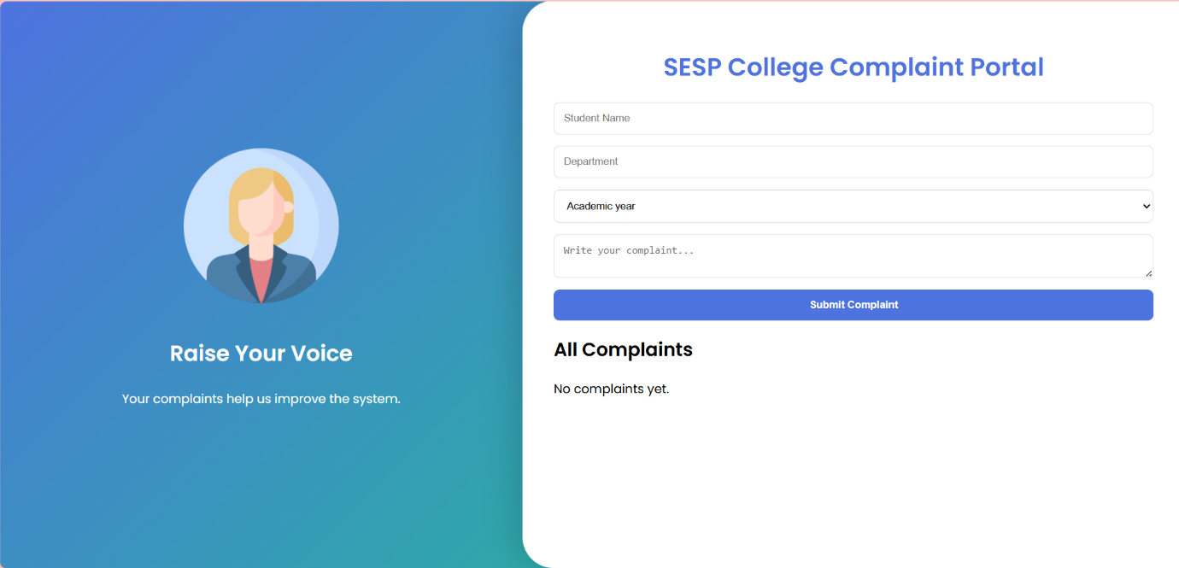
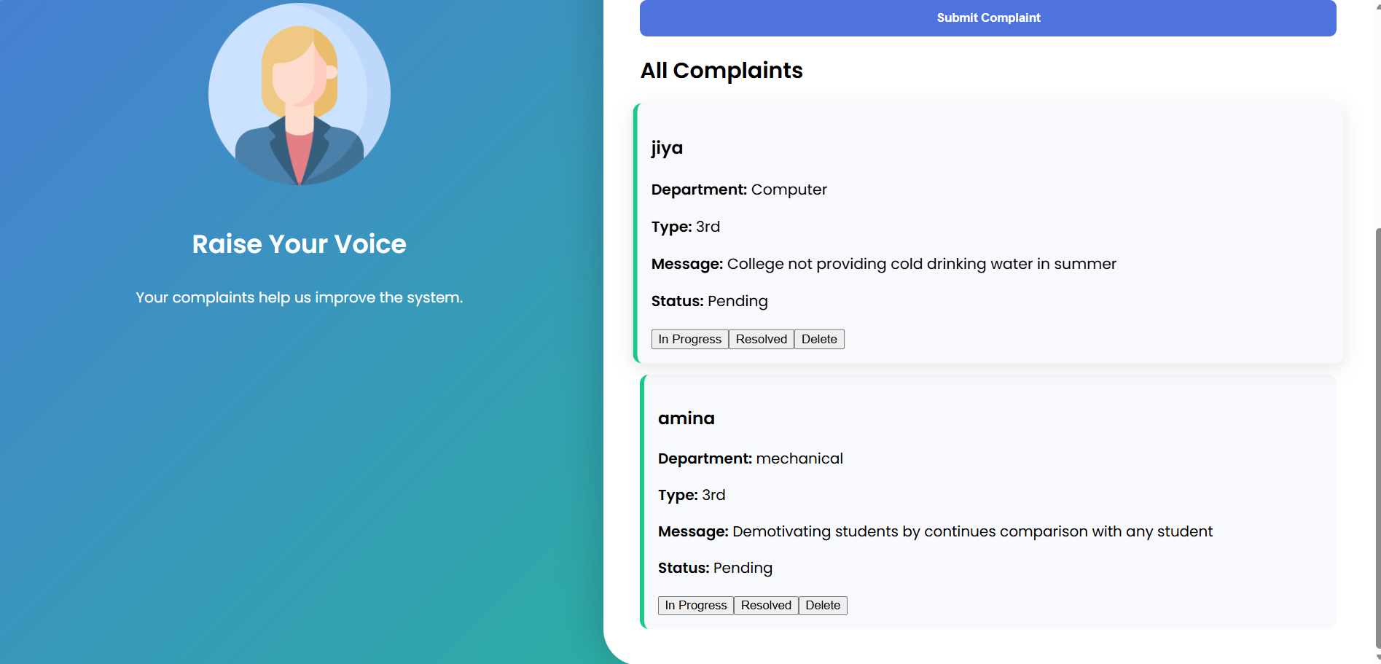
Conclusion
The SESP College Complaint Portal provides a simple and efficient way to manage complaints in a college environment. By using React.js, the system offers a dynamic and interactive interface for users.
The project demonstrates how web technologies can be used to create practical applications that improve communication and management processes. In the future, the system can be enhanced by adding a database, authentication system, and admin dashboard.

References
- React Official Documentation
https://react.dev
- W3Schools Web Development Tutorials
https://www.w3schools.com
- MDN Web Docs
https://developer.mozilla.org

